1. Xpath cheat sheet - <https://gist.github.com/LeCoupa/8c305ec8c713aad07b14>
2. XPATH Evalution on chrome dev tools –

<https://yizeng.me/2014/03/23/evaluate-and-validate-xpath-css-selectors-in-chrome-developer-tools/>

1. CSS Selectors - <https://www.softwaretestinghelp.com/css-selector-selenium-locator-selenium-tutorial-6/>
2. Comparing files without downloading <http://ardesco.lazerycode.com/testing/webdriver/2012/07/25/how-to-download-files-with-selenium-and-why-you-shouldnt.html>
3. Chrome giving popup at starting – unable to load some extension:

And popups while downloading multiple files.

Map<String, Object> chromePreferences = **new** Hashtable<String, Object>();

/* Below two chrome preference settings will disable popup dialog when download file.*/

chromePreferences.put("profile.default_content_settings.popups", 0);

chromePreferences.put( "profile.content_settings.pattern_pairs.*.multiple-automatic-downloads", 1 );

chromePreferences.put( "profile.content_settings.exceptions.automatic_downloads.*.setting", 1 );

chromePreferences.put("download.prompt_for_download", "false");

/* Set file save to directory. */

String downloadLoc = System.*getProperty*("user.home")+"/Downloads/" ;

chromePreferences.put("download.default_directory", downloadLoc);

1. If iframe is present or not – Right click if this frame option is displayed it is a frame.
2. Inside frame to validate xpaths and css are identifying elements or not – F12-> console -> select frame from dropdown in Execution Context Selector and then - $x(“//*[@id=’abc’]”) should show the element. $$(“css sleelector ”).

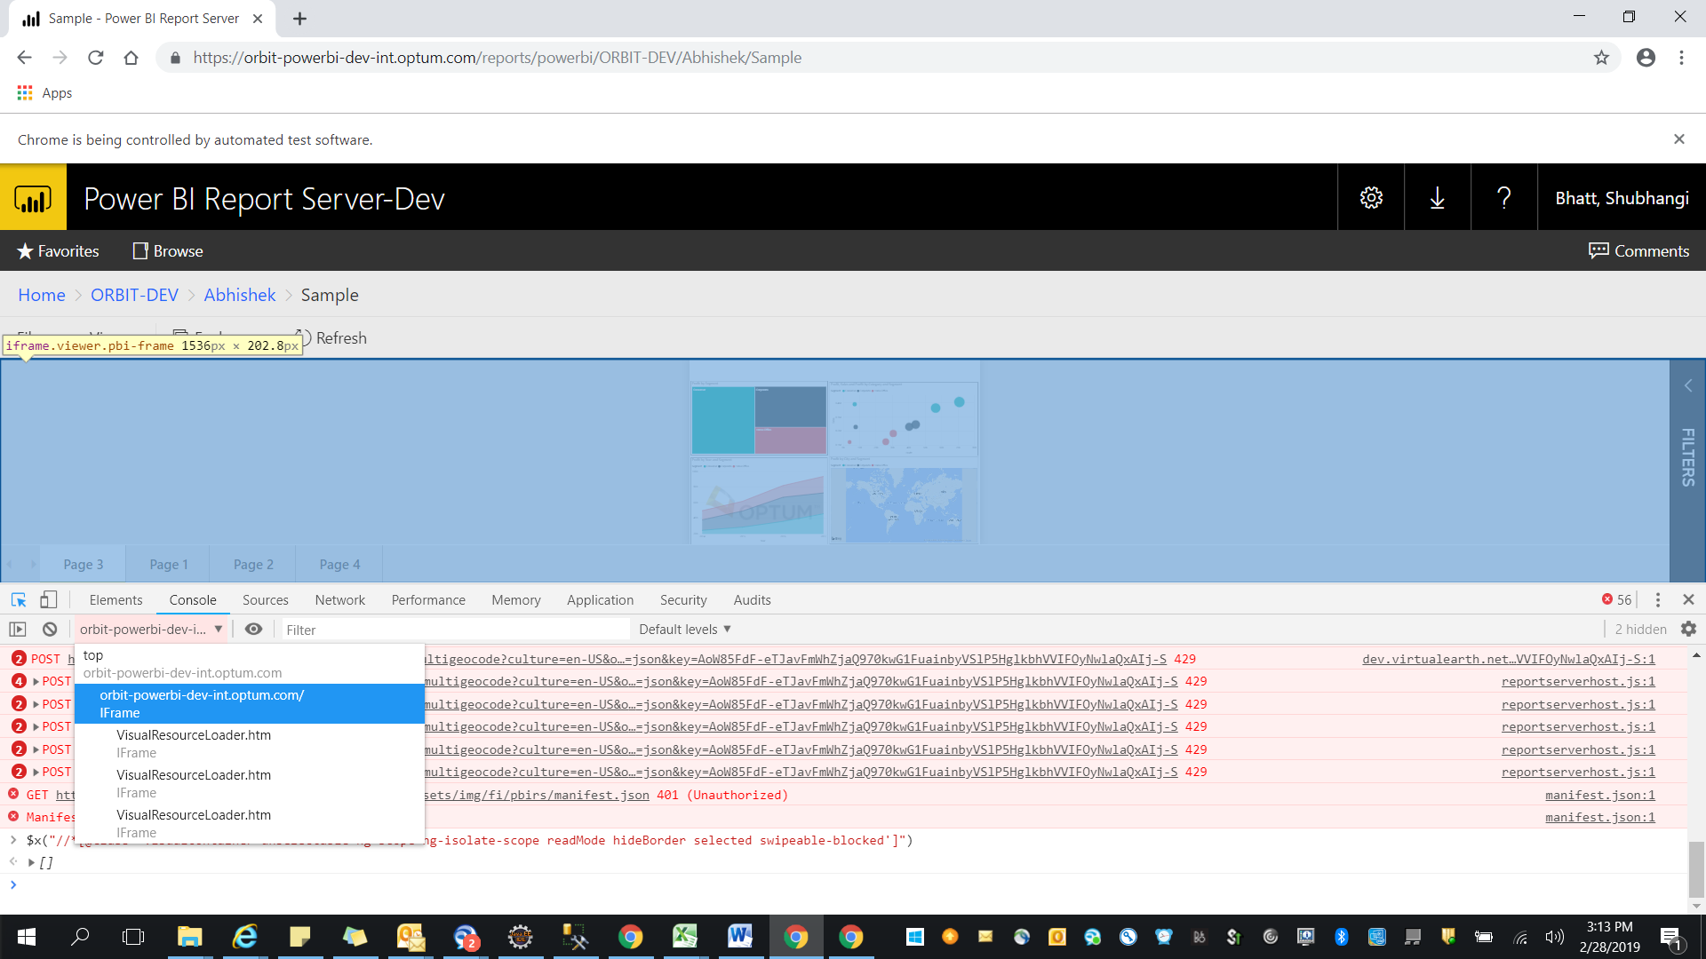

1. Also most of the times although on dev tools element is recognized using xpath but selenium script fails with element not found --- to resolve this try to run script and pick the automated controlled browser and open dev tools and try to search for the element identifier. If the automated controlled chrome is not able to find the element, element might be hidden or visible on hover only. Try sending Tab or clicking on iframe using any identifiable element and then try to click on hidden element
2. Cannot focus on element exception - <https://stackoverflow.com/questions/34537344/getting-cannot-focus-element-in-chrome-and-edge-using-java-selenium>

Try using element.click

Selenium Questions:

IE Browser Issues and resolutions-

<http://toolsqa.com/selenium-webdriver/challenges-to-run-selenium-scripts-with-ie-browser/>

IE Headless – No options available

<https://stackoverflow.com/questions/46645307/how-to-set-capability-for-ie-browser-to-run-in-headless-mode>

<https://github.com/SeleniumHQ/selenium/wiki/DesiredCapabilities>

3.4.1

Native Events - <https://github.com/SeleniumHQ/selenium/wiki/InternetExplorerDriver#required-configuration>

capabilities.set('ignoreProtectedModeSettings', true);

capabilities.set('ie.ensureCleanSession', true);

capabilities.set('enableElementCacheCleanup', true);

DesiredCapabilities cap = DesiredCapabilities.internetExplorer();

cap.setCapability(InternetExplorerDriver.NATIVE_EVENTS, true);

cap.setCapability(InternetExplorerDriver.REQUIREWINDOWFOCUS, true);

cap.setCapability(InternetExplorerDriver.INTRODUCE_FLAKINESS_BY_IGNORING_SECURITY_DOMAINS,true);

WebDriver driver = new InternetExplorerDriver(cap);

<https://stackoverflow.com/questions/48162835/selenium-not-detecting-the-second-window-in-ie>

Issues with chrome – below popup is handled by –

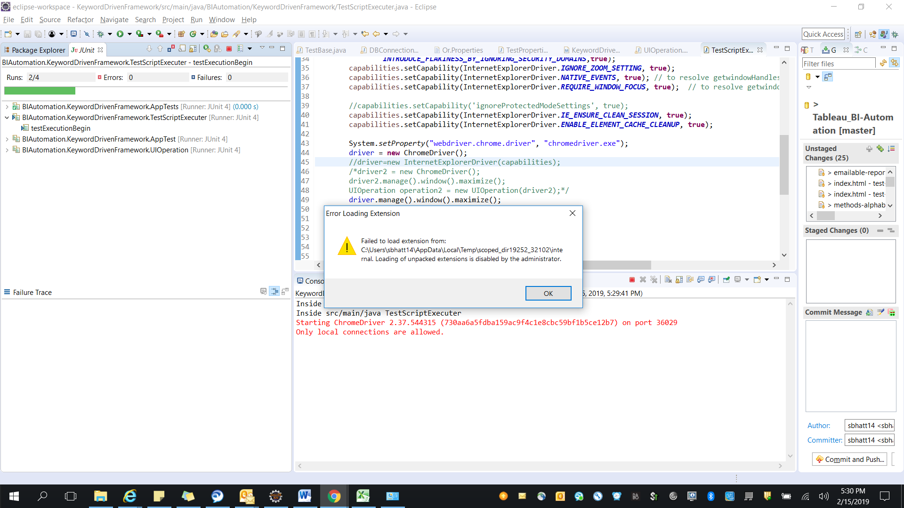

ChromeOptions options = **new** ChromeOptions();

//maximizes window as disabling automation extention will not allow window.maximise to work

options.addArguments("start-maximized");

//disables automatic extension which leads to popups

options.setExperimentalOption("useAutomationExtension", **false**);

<https://stackoverflow.com/questions/43571119/loading-of-unpacked-extensions-is-disabled-by-the-administrator?rq=1>

MAVEN and sqljdbc42 –

Either install sqljdbc driver on maven first using – but this will only install driver to local maven repo. Microsoft (and Oracle and other third party providers) restrict the distribution of their software as per the ENU/EULA. Therefore those software modules do not get added in Maven produced jars for distribution<https://stackoverflow.com/questions/19537396/missing-artifact-com-microsoft-sqlserversqljdbc4jar4-0/30111956#30111956>

<https://stackoverflow.com/questions/6942407/setting-up-maven-dependency-for-sql-server>

or use below

<!-- https://mvnrepository.com/artifact/com.microsoft.sqlserver/mssql-jdbc -->

<dependency>

<groupId>com.microsoft.sqlserver</groupId>

<artifactId>mssql-jdbc</artifactId>

<version>6.1.0.jre8</version>

</dependency>

or for java 7:

<!-- https://mvnrepository.com/artifact/com.microsoft.sqlserver/mssql-jdbc -->

<dependency>

<groupId>com.microsoft.sqlserver</groupId>

<artifactId>mssql-jdbc</artifactId>

<version>6.1.0.jre7</version>

</dependency>